|  |  |
| --- | --- |
| GenderCode | (All) |

|  |  |  |  |  |  |  |  |
| --- | --- | --- | --- | --- | --- | --- | --- |
| **Count of FirstName** | **Column Labels** | | | |  | | |
| **Row Labels** | **Exceeds** | **Fully Meets Needs Improvement** | | | **PIP Grand Total** | | |
| BPC |  | 36 | 235 | 24 | | 8 | 303 |
| CCDR |  | 39 | 234 | 17 | | 10 | 300 |
| EW |  | 39 | 240 | 16 | | 7 | 302 |
| MSC |  | 39 | 226 | 20 | | 11 | 296 |
| NEL |  | 30 | 251 | 11 | | 12 | 304 |
| PL |  | 34 | 241 | 16 | | 10 | 301 |
| PYZ |  | 35 | 228 | 23 | | 13 | 299 |
| SVG |  | 46 | 233 | 20 | | 5 | 304 |
| TNS |  | 41 | 233 | 15 | | 8 | 297 |
| WBL |  | 30 | 240 | 15 | | 9 | 294 |
| **Grand Total** |  | **369** | **2361** | **177** | | **93** | **3000** |

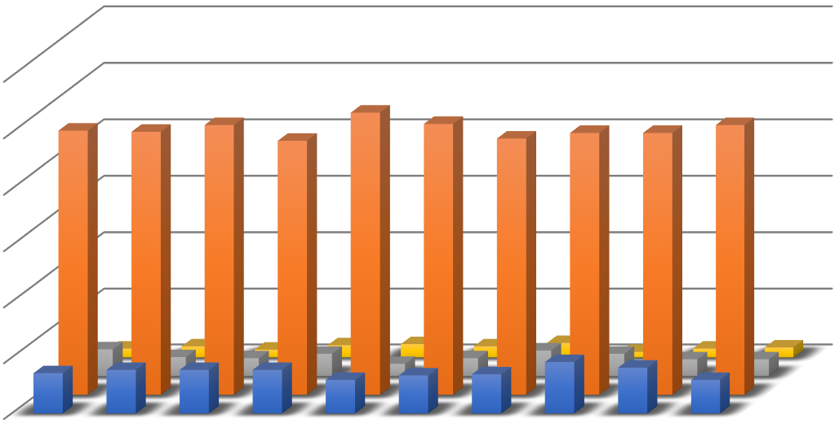

Exceeds

Needs Improvement

0

50

100

150

200

250

300

BPC

CCDR

EW

MSC

NEL

PL

PYZ

SVG

TNS

WBL



Exceeds



Fully Meets



Needs Improvement



PIP